

NAME : BISMA FATIMA
CLASS : CS A
ROLL NO: F24605036
COURSE : COMPUTER NETWORK
COURSE CODE : CS-271
LECTURER : SIR NAVEED YOUSAF

LAB 03

Lab Task 1
By using Drag and drop draw topology diagram as Shown below and attach screenshot of each step.
1. Label each Laptop with unique ip address.
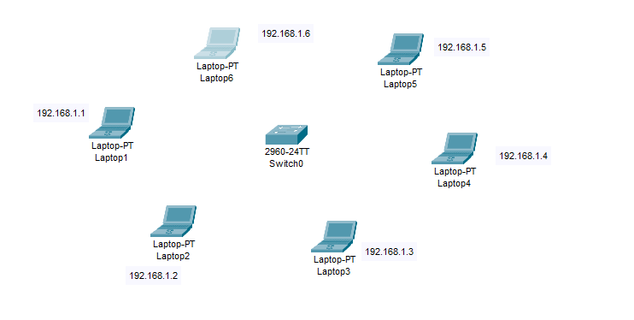
2. Highlight different sections (3).
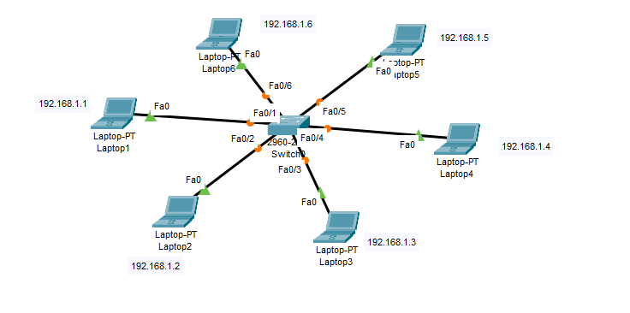
3. ping Laptop1 to Laptop6.
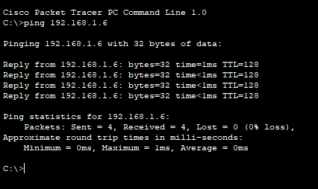
4. ping Laptop2 to Laptop5.
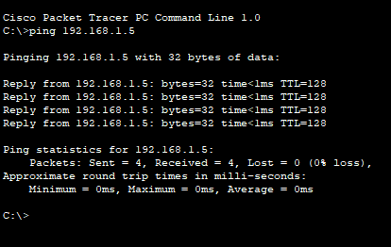
5. ping Laptop6 to Laptop3.
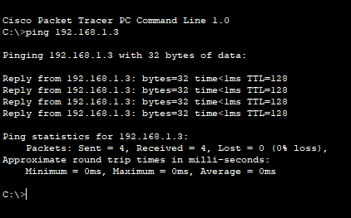

6. Send packet Laptop2 to Laptop4 (Real time).
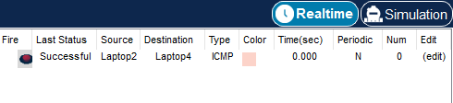
7. Send packet Laptop5 to Laptop1(Simulation).
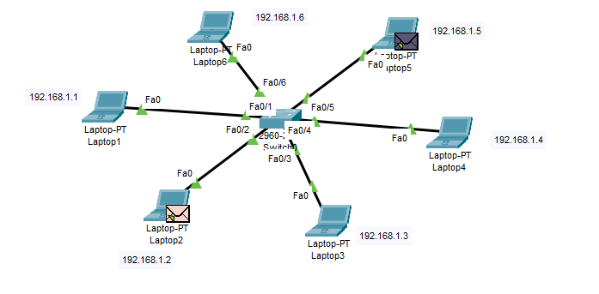
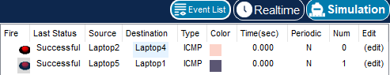
8.Identify topology name
ANS:
The topology used in above question is STAR TOPOLOGY.

Lab Task 02
Mesh Topology (LAN)
- Create a network with 4 PCs (PC1, PC2, PC3, PC4).
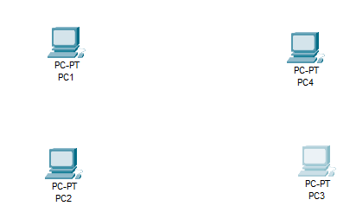
- Connect them in a Mesh topology using switches (each PC must have multiple paths to others).
- Example: Use 4 switches and interconnect them so redundancy exists.
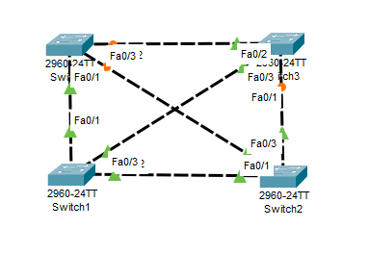
- Assign IP addresses to PCs using the block 192.168.10.0/24.
- Subnet Mask → 255.255.255.0
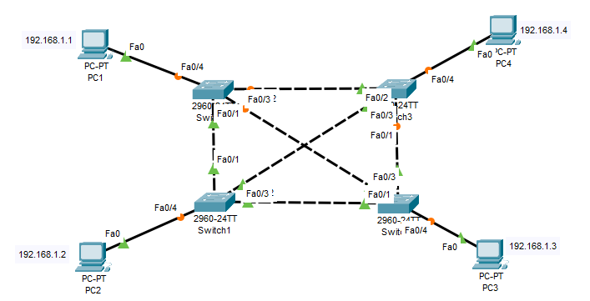
- Test connectivity by pinging between all PCs.
- Ping PC 01 to PC 02
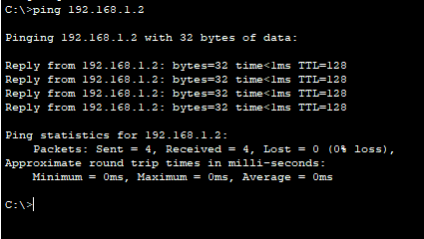

- Ping PC 01 to PC 03
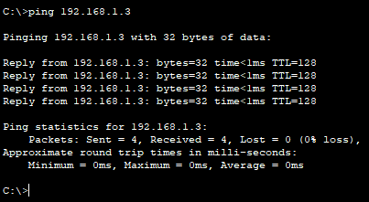
- Ping PC 01 to PC 04
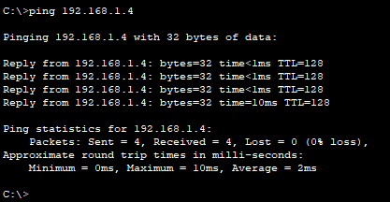
- Label each Laptop with unique ip address.

- Highlight different sections.
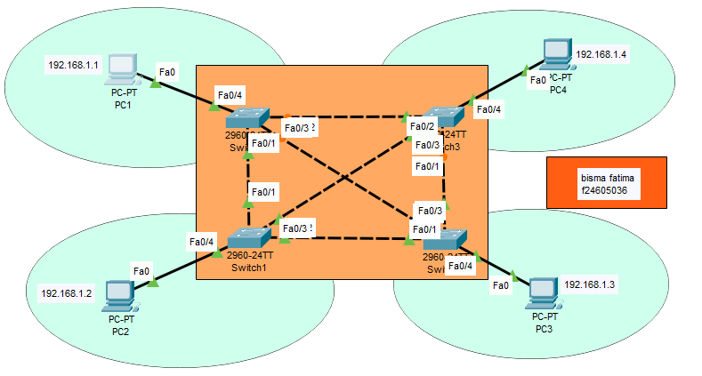
Lab Task 03
Tree Topology (LAN)
- Build a Tree topology with:
- One main switch (Root).
- Two child switches connected to the main switch.
- Each child switch connects to 2 PCs (total 4 PCs).
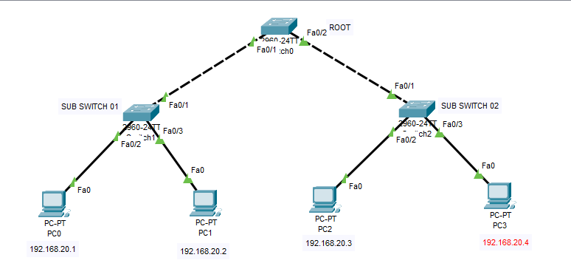
- Assign IP addresses from 192.168.20.0/24
- Subnet Mask → 255.255.255.0
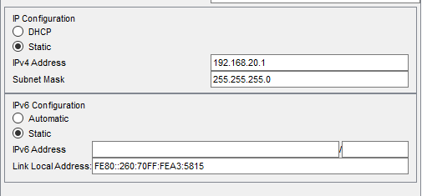
- Similarly assign the ip address to all PC

- Label each Laptop with unique ip address.
Already mentoined in above screenshot
- Test connectivity by pinging from one PC to all others.
- Ping PC 01 to PC 02
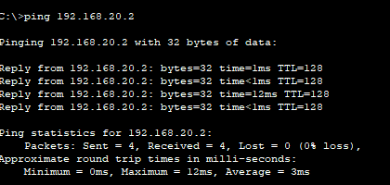

- Ping PC 01 to PC 03

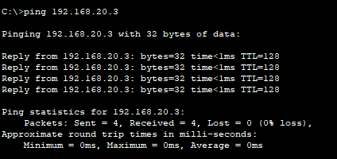
- Ping PC 01 to PC 04
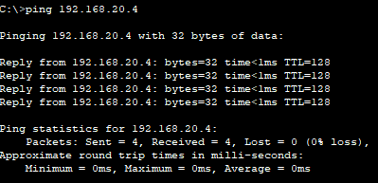

- Similarly we have ping other PC

- Check Results in Both Cases Real-time and Simulation mode ad Screen Shots.
- Real time
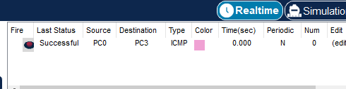
- Simulation mode
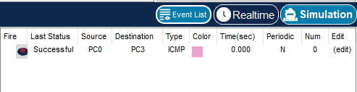

- Label and Highlight Topology with Your name and ID.
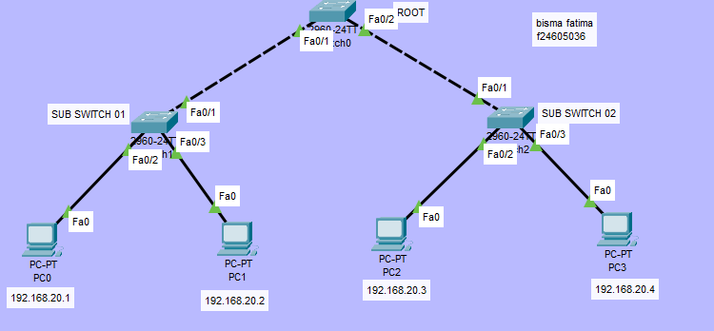

RING TOPOLOGY
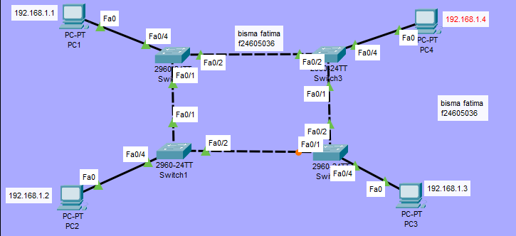
BUS TOPOLOHHY
